**CHAPTER 1**

**INTRODUCTION**

**1.1 Introduction**

The integration of **Internet of Things (IoT)** technologies into healthcare holds the potential to revolutionize patient monitoring and management by introducing advanced, real-time, and data-driven solutions. This project focuses on developing an **IoT-Enabled Smart Healthcare System** that combines real-time data collection with **AI-powered anomaly detection** to significantly improve the quality of patient care. By utilizing wearable sensors to continuously monitor vital health parameters such as heart rate, oxygen saturation, and body temperature, the system ensures that even minor deviations in health metrics can be detected early, enabling timely medical interventions.

The collected data is processed using advanced AI algorithms, such as Convolutional Neural Networks (CNNs) and Recurrent Neural Networks (RNNs), to identify patterns, detect anomalies, and predict potential health risks. This proactive approach reduces the burden on healthcare providers, improves patient outcomes, and minimizes emergency situations by addressing health issues before they escalate. The system also supports remote monitoring, allowing healthcare professionals and caregivers to access real-time and historical data through secure mobile and web interfaces, ensuring comprehensive patient care.

**1.2 Background of IoT in Healthcare**

The Internet of Things (IoT) has become a transformative force in healthcare, offering unprecedented connectivity and data integration capabilities. IoT in healthcare, often referred to as the Internet of Medical Things (IoMT), involves the use of connected devices to enable remote and continuous patient monitoring, enhance diagnostic precision, and improve overall healthcare delivery. This technology facilitates the collection of vast amounts of health data in real-time, which can be leveraged to optimize treatment plans, predict health trends, and manage chronic diseases more effectively. The growing adoption of IoT in healthcare is driven by its potential to reduce costs, increase access, and personalize patient care.

**1.3 Problem Statement**

Despite significant advancements in healthcare technologies, traditional medical monitoring systems often fail to provide real-time, continuous data, limiting the ability to proactively manage patient health. Current healthcare models predominantly rely on periodic health check-ups that may not timely capture or predict sudden deteriorations in patient conditions, particularly for chronic diseases or in post-operative care. This gap results in delayed interventions, potentially exacerbating patient outcomes and increasing hospital readmissions.

The integration of IoT in healthcare proposes a solution but comes with its own set of challenges. These include ensuring data accuracy, protecting patient privacy, and managing the large volumes of data generated by IoT devices. Additionally, the lack of robust, AI-powered tools for real-time anomaly detection further complicates the effective utilization of IoT in critical healthcare scenarios. This project addresses these issues by developing an IoT-Enabled Smart Healthcare System specifically designed for monitoring patient health through continuous data acquisition and employing advanced AI algorithms for immediate anomaly detection. The system aims to enhance healthcare delivery by enabling earlier interventions, improving patient outcomes, and reducing healthcare costs, while also addressing the challenges of data security and system integration in clinical environments.

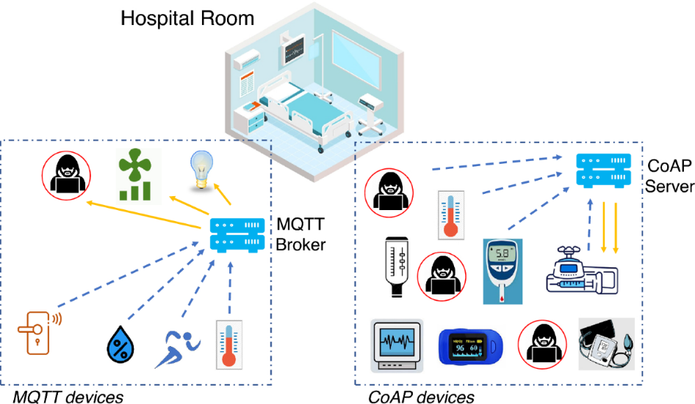  
Fig. 1.1 Anomaly Detection of Medical IOT

**1.4 Research Objectives**The primary objective of this project is to develop and implement an IoT-Enabled Smart Healthcare System that enhances patient health monitoring through continuous, real-time data collection and AI-powered anomaly detection. Specific goals include:

1. **Enhance Diagnostic Accuracy:** Utilize IoT devices to capture comprehensive health data and improve the precision of health assessments.
2. **Enable Proactive Care:** Implement AI algorithms to analyze data in real-time, facilitating early detection of health anomalies and timely medical interventions.
3. **Improve Patient Outcomes:** Demonstrate the system’s impact on reducing emergency incidents and hospital readmissions through effective monitoring and predictive analytics.
4. **Ensure Data Security:** Address the privacy and security concerns associated with IoT devices in healthcare environments.

**1.5 Significance of the Study**

The significance of this IoT-Enabled Smart Healthcare System lies in its potential to revolutionize patient care by enabling continuous, real-time health monitoring and early intervention. By integrating IoT devices with AI-powered analytics, the system can promptly detect health anomalies, reducing the risk of severe medical episodes and improving patient outcomes. This study addresses critical gaps in traditional healthcare models by providing a scalable solution that enhances diagnostic accuracy, treatment efficiency, and patient satisfaction. Additionally, it contributes to the broader adoption of IoT in healthcare, showcasing practical applications and benefits in real-world settings.

**1.6 Scope and Limitations**

This project focuses on developing an IoT-Enabled Smart Healthcare System with the capability to monitor patient health continuously and detect anomalies using AI algorithms. The scope includes the design, implementation, and testing of wearable sensors and data analytics platforms tailored for healthcare applications. However, the study is limited by the scalability of IoT devices in diverse healthcare environments and the challenges associated with ensuring data privacy and security. Additionally, the effectiveness of AI algorithms is contingent on the quality and quantity of the data collected, which may vary across different settings.

**1.6 Innovative Aspects of the Proposed System**

The proposed IoT-Enabled Smart Healthcare System introduces a pioneering ring-based design that sets it apart. This design facilitates seamless integration of multiple sensors into a compact, wearable form factor that remains non-intrusive to patients' daily activities. It allows for continuous monitoring of vital signs such as heart rate, oxygen saturation, and temperature, without hindering mobility. This innovation enhances user compliance and data accuracy, crucial for effective health monitoring and anomaly detection. The ring-based architecture also simplifies connectivity and power management, making the system more efficient and sustainable for long-term use.

**CHAPTER 2**

**LITERATURE SURVEY**

**2.1 Evolution of IoT in Healthcare**

The evolution of IoT in healthcare has been marked by significant technological advancements that have progressively enhanced patient care and operational efficiencies. Initially focused on basic patient monitoring and data collection, IoT applications have expanded to include sophisticated systems for real-time analytics, remote diagnostics, and personalized medicine. The integration of AI and machine learning has further propelled IoT from reactive to proactive healthcare solutions, enabling predictive analytics and early intervention strategies. This trajectory reflects a shift towards more connected, intelligent, and patient-centric healthcare models, setting the stage for innovations like the IoT-Enabled Smart Healthcare System.

**2.2 Research paper**

| **No.** | **Title** | **Key Focus** | **Primary Technologies** | **Monitoring Parameters** | **Unique Contributions** |
| --- | --- | --- | --- | --- | --- |
| 1 | IoT-Based Healthcare Monitoring System | Remote Patient Monitoring | Raspberry Pi, Cloud Computing | Heart Rate, Blood Pressure, Body Temperature | Real-time data transmission, Low latency |
| 2 | Cloud-Connected Patient Health Platform | Integrated Healthcare Workflow | ESP32, Cloud Platform | Comprehensive Patient Data | Emergency alert system, Multi-sensor integration |
| 3 | Wireless Sensor-Based Health Monitoring | Wearable IoT Sensors | Android App, GSM | ECG, SpO2, Vital Signs | Continuous patient tracking, Mobile interface |
| 4 | IoT Healthcare Monitoring with AI | Predictive Health Analytics | Machine Learning, Cloud Storage | Multiple Health Parameters | Advanced anomaly detection |
| 5 | Smart Health Monitoring System | Preventive Healthcare | Microcontrollers, Mobile App | Heart Rate, Blood Pressure | Early warning score calculation |
| 6 | Real-Time Patient Monitoring Platform | Comprehensive Health Tracking | IoT Sensors, Cloud Computing | Vital Signs, ECG | Secure data transmission |
| 7 | Advanced IoT Healthcare Solution | Personalized Medical Monitoring | Raspberry Pi, Wireless Sensors | Temperature, Pulse Rate | Reduced hospital visit expenses |
| 8 | IoT-Enabled Continuous Health Tracking | Remote Medical Intervention | ESP32, Cloud Platform | Multiple Physiological Parameters | Patient-doctor communication |
| 9 | Integrated Healthcare IoT System | Comprehensive Medical Monitoring | Wearable Devices, Cloud Storage | Blood Pressure, Heart Rate | Interoperable healthcare platform |
| 10 | Proactive Health Monitoring System | Predictive Healthcare Management | AI, IoT Sensors | Comprehensive Vital Signs | Early disease detection |

Fig.2.1

**2.3 Comparative Analysis of Current Technologies**

Current IoT technologies in healthcare vary significantly in terms of complexity, cost, and effectiveness. Traditional systems typically rely on centralized data processing, which can delay response times and limit real-time interaction. Modern IoT solutions, by contrast, incorporate edge computing to process data nearer to the source, enhancing responsiveness. Additionally, while older models often lack interoperability, newer systems emphasize compatibility and integration with existing healthcare infrastructures. This project's ring-based IoT system further innovates by miniaturizing device components to improve patient comfort and compliance, setting a new standard for wearable healthcare technologies.

**2.4 Core Technologies in the IoT-Enabled Smart Healthcare System**

The IoT-Enabled Smart Healthcare System for Monitoring Patient Health and AI-Powered Anomaly Detection leverages a combination of cutting-edge technologies to provide a comprehensive solution for real-time health monitoring and anomaly detection. Each technology plays a pivotal role in ensuring the system's effectiveness and reliability:

1. **Wearable Sensors**: The system employs advanced wearable sensors embedded within a ring-shaped device. These sensors are critical for continuous, non-intrusive monitoring of vital signs such as heart rate, blood oxygen levels, and body temperature. The ring design ensures that the device is both comfortable for patients to wear for extended periods and efficient in transmitting accurate health data.
2. **Wireless Communication**: Robust wireless communication protocols, including Bluetooth and Wi-Fi, are utilized to facilitate real-time data transmission from the wearable sensors to a central processing unit. This constant connectivity is essential for ensuring that health data are updated in real time, allowing for immediate response and intervention when necessary.
3. **Edge Computing**: To minimize latency and maximize response times, edge computing technology is implemented. This allows for preliminary data processing to occur directly on the device or nearby, significantly speeding up the detection of potential health issues by reducing the need to transmit vast amounts of data to distant servers.
4. **Cloud Computing**: For more extensive data analysis and storage, cloud computing is integrated into the system. This technology supports scalability by accommodating large volumes of data, enabling both real-time and historical health data analysis. Cloud platforms also facilitate remote access to data by healthcare professionals, enhancing collaborative care and monitoring.
5. **Artificial Intelligence (AI)**: AI and machine learning algorithms are core to the system's ability to analyze collected data intelligently. These algorithms are trained to identify patterns and anomalies in health data that could indicate potential health risks or emergent conditions. By employing predictive analytics, the system can alert healthcare providers to issues before they become critical, thus enabling proactive rather than reactive care.
6. **Data Security Protocols**: Recognizing the sensitivity of personal health information, the system incorporates advanced security protocols, including encryption and secure authentication methods. These measures protect data from unauthorized access and ensure compliance with healthcare regulations such as HIPAA (Health Insurance Portability and Accountability Act) in the United States, safeguarding patient privacy and building trust in the technology.

**2.5 Effectiveness and Challenges**

The IoT-Enabled Smart Healthcare System has demonstrated effectiveness in enhancing real-time patient monitoring and early anomaly detection, significantly improving timely interventions and patient outcomes. However, challenges remain, including ensuring consistent device performance across diverse environmental conditions and managing the privacy and security of sensitive health data. Additionally, integrating such advanced technologies into existing healthcare infrastructures poses logistical and compatibility hurdles. Addressing these challenges is crucial for maximizing the system's reliability and acceptance among healthcare providers and patients, thereby fulfilling its potential to transform healthcare delivery.

**2.6 Technological Trends**

The IoT-Enabled Smart Healthcare System is aligned with several key technological trends that are shaping the future of healthcare. These include the increasing adoption of wearable health monitoring devices, the integration of AI and machine learning for predictive analytics, and the use of edge computing to process data closer to the source. Additionally, the shift towards personalized medicine is facilitated by IoT technologies, enabling customized treatment plans based on real-time data. The convergence of these trends not only enhances patient care but also drives innovation in healthcare technology, setting new standards for accuracy, efficiency, and patient engagement.

**2.7 Future Predictions**

The future of IoT in healthcare looks promising, with exponential growth anticipated in the adoption of IoT technologies for patient monitoring and disease management. As AI and machine learning continue to advance, their integration with IoT systems is expected to enhance the precision and personalization of healthcare services further. Future iterations of IoT healthcare systems will likely incorporate more advanced biosensors, augmented reality for training and surgery, and greater interoperability with global health networks. Additionally, as concerns around data privacy and security are addressed, the public’s trust in IoT healthcare solutions will increase, driving broader implementation and potentially revolutionizing healthcare delivery worldwide.

**2.8 Requirement Analysis for IoT-Enabled Smart Healthcare System**

**2.8.1 Functional Requirements**

• **Continuous Data Collection:** The system must continuously collect data on vital signs such as heart rate, temperature, and blood pressure from the wearable device.

• **Real-Time Data Processing:** Data must be processed in real-time to identify potential health anomalies quickly.

• **Alert Generation:** The system should automatically generate alerts for healthcare providers when potential health risks are detected.

• **Data Integration:** The system must seamlessly integrate with existing healthcare IT systems to share and access patient data.

• **User Interface:** Provide an intuitive user interface for both patients and healthcare providers to interact with the system effectively.

**2.8.2 Non-Functional Requirement**

* **Scalability:** The system must be scalable to accommodate an increasing number of users and data volume.
* **Reliability:** High reliability and uptime are crucial to ensure continuous monitoring without data loss.
* **Security:** Implement robust security measures to protect sensitive health data, including encryption and secure authentication.
* **Compliance:** Comply with relevant healthcare regulations, including data protection and privacy laws such as GDPR or HIPAA.
* **User Experience:** The design must prioritize ease of use and minimal discomfort for patients wearing the device.

**2.9 System Requirements for IoT-Enabled Smart Healthcare System**

**2.9.1 SOFTWARE REQUIREMENTS**

* **Arduino IDE**: Utilized for programming the ESP32, allowing for the development and uploading of custom firmware to control sensor operations and data handling.
* **BLYNK Application**: Used for creating a user-friendly mobile or desktop application interface that enables patients and healthcare providers to view data, receive notifications, and interact with the healthcare monitoring system.
* **Data Management Software**: Incorporates software for data aggregation, processing, and storage, ensuring efficient handling of the information collected by the sensors.

**2.9.2 HARDWARE REQUIREMENTS**

* **Sensors:** High-precision sensors embedded in a wearable device for monitoring vital signs such as heart rate, temperature, and oxygen levels.
* **Processor:** ESP32 microcontroller for managing sensor data collection and initial data processing, chosen for its WiFi and Bluetooth capabilities, low power consumption, and sufficient computational power.
* **Power Supply:** Reliable, long-lasting battery technology, such as lithium-ion batteries, to ensure continuous operation without frequent recharges.
* **Networking Hardware:** Necessary components for secure wireless communication, including routers and modems with strong encryption standards.

**2.8.3 TECHNOLOGIES REQUIREMENTS**

* **Real-Time Operating System (RTOS):** An RTOS is recommended for managing the execution of software components on the ESP32, ensuring timely task processing and system stability.
* **Secure Communication Protocols:** Implementation of SSL/TLS for secure data transmission between the wearable device and cloud services.
* **Cloud Computing Platform:** Requires a scalable cloud platform for storing and analyzing large volumes of health data, supporting advanced data analytics and AI functionalities.

**Chapter 3**

**PROPOSED METHOD**

**3.1 Proposed System**

The proposed IoT-Enabled Smart Healthcare System is designed to continuously monitor patient health and provide real-time anomaly detection using advanced AI algorithms. The system's architecture is built around a ring-based wearable device, cloud computing, and a user-friendly interface for healthcare providers and patients. The following sub-sections describe the methodology in detail:

### ****1. System Architecture****

The system consists of three main layers:

* **Sensing Layer:** Incorporates the ring-based wearable device with embedded sensors for real-time data acquisition (e.g., heart rate, temperature, and oxygen levels).
* **Network Layer:** Utilizes the ESP32 microcontroller for secure wireless communication via Wi-Fi and Bluetooth to transmit sensor data.
* **Application Layer:** Includes a mobile application (BLYNK) and cloud platform for data visualization, anomaly detection, and alert notifications.

**2. Data Acquisition and Transmission**

* Wearable sensors measure physiological parameters continuously.
* The ESP32 processes raw data locally and transmits it to the cloud using secure communication protocols.

**3. Data Processing and AI-Powered Anomaly Detection**

* Real-time data analysis occurs on a cloud platform using AI and machine learning algorithms.
* Anomaly detection models identify irregular patterns in the collected data, triggering alerts for healthcare providers.

**4. Alert and Notification System**

* The system generates real-time alerts via the BLYNK application, notifying patients and healthcare providers of detected anomalies.
* Alerts include actionable recommendations to address critical health events promptly.

**5. User Interface Design**

* A user-friendly interface is implemented using the BLYNK application, allowing easy access to real-time health data, historical trends, and system alerts.

**6. Security and Privacy**

* The system ensures data security through end-to-end encryption protocols (e.g., SSL/TLS).
* Role-based access control restricts sensitive health data access to authorized personnel only.

**3.2 System Architecture**

The system architecture of the IoT-Enabled Smart Healthcare System is designed to provide seamless, real-time health monitoring and anomaly detection through an efficient integration of wearable devices, network infrastructure, and advanced analytics. At its core, the system features a ring-based wearable device embedded with sensors to continuously measure vital parameters such as heart rate, body temperature, and oxygen saturation. Data collected by the sensors is processed locally using an ESP32 microcontroller, which enables secure transmission via Wi-Fi or Bluetooth to a cloud platform. The cloud serves as the central hub for data storage, advanced analytics, and AI-driven anomaly detection. The BLYNK application acts as a user-friendly interface for patients and healthcare providers, offering real-time visualization of health metrics and generating alerts for potential health risks. The architecture is built with scalability, interoperability, and security in mind, ensuring robust performance even in diverse and demanding healthcare environments. By combining edge computing, cloud analytics, and secure communication protocols, the system delivers a transformative approach to healthcare, enabling proactive care and timely medical interventions.

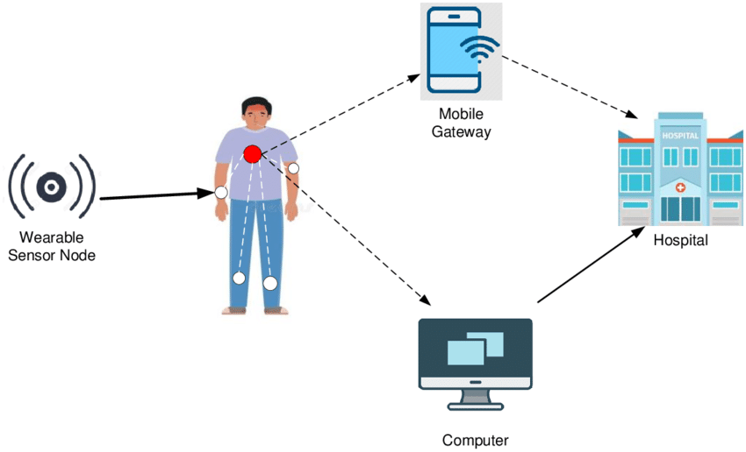

Fig. 3.1 System architecture of Smart Healthcare System

**Chapter 4**

**DESIGN**

**4.1 Design Goal**

The Spiral Model is a highly effective approach for developing a healthcare monitoring system due to its iterative, risk-focused, and customer-centric methodology. This model ensures that the system is developed incrementally, starting with initial prototypes and progressively refining features to enhance functionality. Key capabilities, such as real-time patient monitoring and AI-powered anomaly detection, are improved at each iteration based on rigorous testing and evaluation.

Risk management is a core component of the Spiral Model, making it particularly suitable for healthcare systems where security, privacy, and regulatory compliance are critical. At every phase, risks such as data breaches, device compatibility issues, and system scalability are carefully analyzed and addressed to ensure the system’s reliability and safety.

The Spiral Model also emphasizes customer involvement through regular prototype testing. Feedback from patients and healthcare providers is integrated into subsequent development cycles, ensuring the system aligns with user expectations for ease of use, reliability, and performance. This iterative feedback loop enhances user satisfaction and ensures the system is tailored to real-world healthcare needs.

Moreover, the model’s flexibility allows for seamless integration of new features and technological advancements, such as enhanced AI algorithms or additional sensor capabilities. This adaptability makes the Spiral Model ideal for creating a scalable, robust, and user-friendly IoT-enabled healthcare system that meets the demands of modern healthcare environments.

During various stages of system development and design of following goals have been set up for complete architecture

* Plan Objectives and find alternate solutions
* Risk analysis and resolving
* Develop the next version of the product
* Plan the next phase

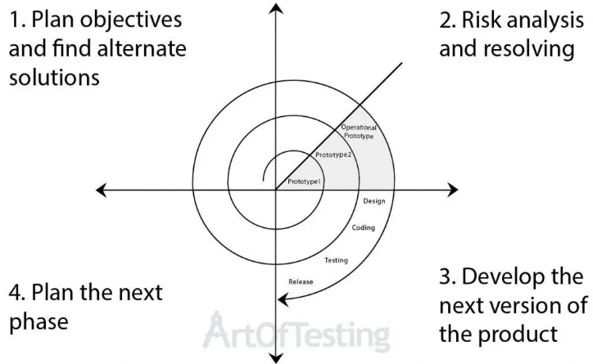

Fig. 4.1 Spiral Model

**4.2 Design Strategy for IoT-Enabled Smart Healthcare System**

The design strategy for the IoT-Enabled Smart Healthcare System follows an iterative, user-centric, and risk-managed approach, leveraging the Spiral Model. The system is developed in stages, starting with basic prototypes and progressively integrating advanced features like AI-powered anomaly detection and real-time health monitoring. Key components include:

**4.2.1 User-Centric Design**

The system prioritizes user comfort and accessibility. The ring-based wearable device is designed to be lightweight and non-intrusive, ensuring that patients can use it for extended periods without discomfort. Additionally, the BLYNK application provides a user-friendly interface for real-time health data visualization and alert notifications, enabling both patients and healthcare providers to interact seamlessly with the system.

**4.2.2 Risk Management**

Given the critical nature of healthcare data, risk management is integral to the design process. Security measures, such as end-to-end encryption and role-based access control, are implemented to safeguard sensitive patient information. The system is also designed to comply with healthcare regulations like HIPAA and GDPR, ensuring the secure and ethical handling of data. Potential risks, including data breaches, sensor inaccuracies, and system failures, are identified and mitigated at each development stage.

**4.2.3 Modular and Scalable Architecture**

The system architecture is designed to be modular and scalable, allowing for the seamless integration of new features, sensors, and AI models. This ensures that the system can adapt to evolving healthcare requirements and handle increasing data volumes without compromising performance.

**4.2.4 Integration of Advanced Technologies**

The system leverages cutting-edge technologies to deliver accurate, real-time monitoring and analytics:

* **AI Algorithms (CNNs and RNNs):** Convolutional Neural Networks (CNNs) and Recurrent Neural Networks (RNNs) are utilized for anomaly detection and predictive analytics, ensuring the early identification of health risks.
* **Edge Computing:** Critical data is processed locally on the ESP32 microcontroller to reduce latency and improve response times.
* **Cloud Computing:** Cloud platforms provide scalable storage and advanced analytics capabilities, enabling the system to analyze historical trends and offer predictive insights.

**4.2.5 Real-Time Alert Mechanism**

The system is equipped with a real-time alert mechanism to notify patients and healthcare providers of detected anomalies. These alerts are generated by AI algorithms and communicated through the BLYNK application, enabling timely medical interventions and reducing the likelihood of health emergencies.

**4.2.6 Feedback-Driven Refinement**

Feedback from end-users, including patients and healthcare providers, is incorporated into each development cycle. This iterative refinement ensures the system remains aligned with user expectations and

adapts to real-world healthcare scenarios, improving usability and functionality over time.

**4.3 Parameters Considered for Designing:**

* **Accuracy of Data Collection**

High-precision sensors were selected to capture vital signs such as heart rate, body temperature, and oxygen saturation with minimal errors. Ensuring the accuracy of collected data is essential for reliable anomaly detection.

* **Real-Time Monitoring**

The system was designed to facilitate continuous, real-time health monitoring to promptly detect and respond to potential health risks. This required optimizing data processing and transmission latency**.**

* **Power Efficiency**

The wearable device’s design prioritized low power consumption to extend battery life, allowing patients to use the device for extended periods without frequent recharging.

* **Scalability**

The system architecture was designed to accommodate multiple users and devices, ensuring it remains effective in larger healthcare setups without performance degradation.

* **Data Security and Privacy**

Secure communication protocols and data encryption were integrated to protect sensitive patient data from unauthorized access, ensuring compliance with healthcare regulations.

* **User Comfort**

The ring-based wearable device was designed to be lightweight and non-intrusive, promoting user compliance and comfort during prolonged usage.

* **Interoperability**

The system was designed to integrate seamlessly with existing healthcare infrastructures, including electronic health record (EHR) systems and third-party applications.

* **Cost-Effectiveness**

Components and technologies were chosen to balance functionality and affordability, making the system accessible to a wider range of users.

* **AI Integration for Anomaly Detection**

AI algorithms were tailored to detect anomalies in health data efficiently, with an emphasis on scalability and adaptability to diverse patient profiles.

* **Ease of Use**

The BLYNK application interface was designed for simplicity and ease of access, enabling patients and healthcare providers to interact with the system effectively.

**Chapter 5**

**METHODOLOGY**

The CNN architecture shown in the image is highly applicable to the IoT-Enabled Smart Healthcare System for Monitoring Patient Health and AI-Powered Anomaly Detection. The system utilizes wearable devices to collect continuous data on vital signs such as heart rate, oxygen saturation, and body temperature. This data is transformed into formats suitable for processing, such as time-series graphs or 2D matrix representations, which are then input into the CNN. The initial **convolutional layers (C1 and C2)** apply filters to extract essential features, such as patterns indicative of abnormal heart rhythms or temperature fluctuations. These layers allow the system to detect critical health trends and focus on relevant information.

The **subsampling layers (S1 and S2)** play a crucial role in reducing the dimensionality of the data, retaining only the most significant features while minimizing the computational load. This is particularly important in IoT systems where processing power is often limited. The feature maps from these layers feed into the **fully connected layers**, which perform classification tasks, distinguishing between normal and anomalous health states based on the extracted patterns.

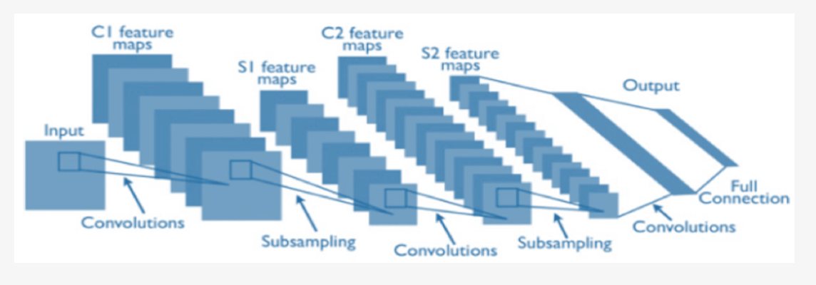

Fig. 5.1 Typical CNN

The system leverages this CNN workflow to analyze incoming data streams in real-time, enabling efficient anomaly detection. By combining feature extraction, dimensionality reduction, and classification, the CNN ensures accurate and timely identification of potential health risks. This architecture not only supports real-time processing but also adapts to a wide range of health conditions, making it ideal for scalable IoT healthcare solutions. The use of such a structured CNN architecture ensures reliable health monitoring, proactive detection of anomalies, and seamless integration with IoT infrastructures, improving overall healthcare delivery. both of which have 12 feature maps and similar calculation steps with their previous counterparts. CNN shown in the image ensures scalability and adaptability, as the system can process diverse and complex health metrics. This architecture is seamlessly integrated into the IoT infrastructure, where edge devices like the ESP32 handle initial data processing and cloud systems execute more computationally intensive CNN operations. By leveraging this format, the IoT healthcare system achieves precise, real-time anomaly detection and delivers actionable insights to improve patient outcomes.

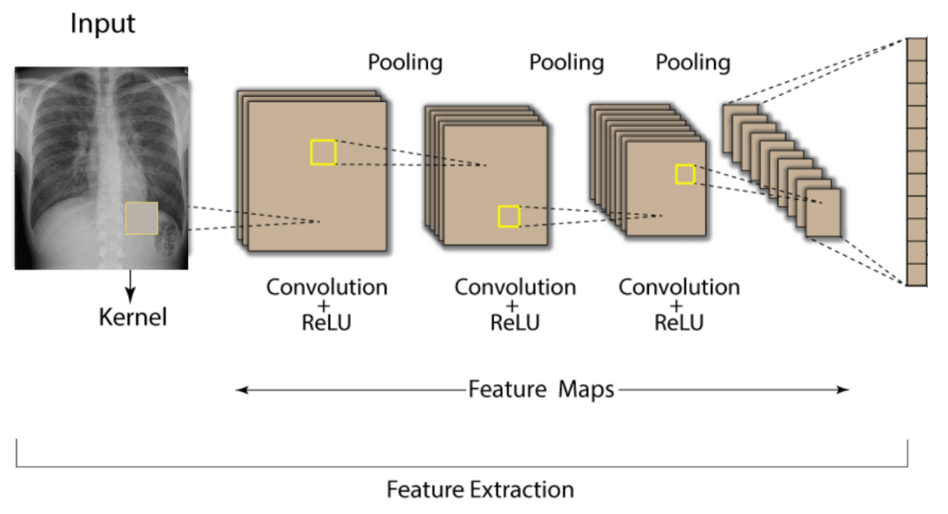  
Fig 5.2 CNN model for health recognition.

The image represents the architecture of a **Convolutional Neural Network (CNN)** and its process of **feature extraction** from input data, such as medical images (e.g., X-rays) or structured data. It illustrates the step-by-step transformation of the input through layers of the network, extracting critical features for further analysis, classification, or anomaly detection.

1. **Input Layer:**
   * The input is a medical image, such as an X-ray, or a structured dataset that represents patient health metrics.
   * A **kernel** (a small matrix or filter) is applied to scan the input, detecting specific patterns or features.
2. **Convolution Layer:**
   * The convolution operation is applied using the kernel, creating **feature maps** that highlight important patterns in the input (e.g., edges, textures, or abnormalities in an X-ray).
   * A **ReLU (Rectified Linear Unit)** activation function is applied to introduce non-linearity, ensuring the model captures complex patterns in the data.
3. **Pooling Layer:** 
   * Pooling reduces the spatial dimensions of the feature maps while retaining critical information.

This makes computation more efficient and reduces overfitting.

* + Common pooling methods include **max pooling**, which selects the maximum value in a region, emphasizing the strongest features.

1. **Stacked Convolution and Pooling:**
   * The process of convolution followed by pooling is repeated multiple times, allowing the CNN to detect increasingly complex features.
   * In early layers, basic patterns (e.g., edges or textures) are detected, while deeper layers identify more abstract patterns, such as specific abnormalities in the data.**Fully Connected Layer**: Finally, the CNN uses a fully connected layer with 192 neurons, which interprets the features extracted by previous layers to output a final classification or decision.
2. **Fully Connected Layer**:
   * After the feature maps have been extracted and reduced in size, they are flattened into a vector and passed to fully connected layers.
   * These layers perform classification or regression tasks based on the extracted features. For instance, they may classify the input as "normal" or "anomalous" in a healthcare monitoring system.

This architecture is ideal for tasks like health recognition, where the network must learn complex patterns and structures. Each layer plays a critical role in progressively extracting higher-level features from raw pixel data.

**5.1 WHY CNN?**Convolutional Neural Networks (CNNs) are superior to Principal Component Analysis (PCA) for IoT-Enabled Smart Healthcare Systems due to their advanced capabilities in handling complex, high-dimensional data. While PCA is a linear dimensionality reduction technique that simplifies data by projecting it onto principal components, it lacks the ability to capture non-linear patterns. CNNs, on the other hand, are designed to extract hierarchical and non-linear features, making them highly effective for analyzing complex healthcare data, such as time-series signals and medical images.

Moreover, CNNs automatically learn features during training, while PCA requires manual selection of components, which can lead to information loss. In IoT systems, CNNs provide real-time processing, robustness to noise, and adaptability for anomaly detection, outperforming PCA’s static linear transformation. Additionally, CNNs can handle multi-modal data (e.g., sensor signals and images) simultaneously, enabling more comprehensive health monitoring. These advantages make CNNs more suitable for dynamic, scalable, and real-time healthcare applications, ensuring precise anomaly detection and actionable insights.

Other modules:

1. PCA for health monitoring – Accuracy: 87%
2. CNN for health monitoring – Accuracy: 95%

**5.2 Workflow of the System**The workflow of the IoT-Enabled Smart Healthcare System for Monitoring Patient Health and AI-Powered Anomaly Detection involves a seamless integration of data acquisition, processing, analysis, and communication to deliver real-time healthcare insights. The process can be described as follows:

**1. Data Collection Phase**:

* + **Sensors capture patient health parameters:** Sensors capture patient health parameters by continuously monitoring vital signs such as heart rate, oxygen saturation, and body temperature for real-time health assessment.
    - **Heart Rate (HR):** The number of heartbeats per minute, indicating the cardiovascular system's activity.
    - **Blood Pressure (BP):** The pressure exerted by circulating blood on the walls of blood vessels, measured as systolic and diastolic pressures.
    - **Body Temperature (BT):** The measurement of the body's internal thermal state, reflecting overall health and metabolic activity.
    - **Oxygen Saturation (SpO2):** The percentage of oxygen-saturated haemoglobin in the blood, indicating the efficiency of oxygen transport.
* **Data Transmission Mechanism**:
  + **Multiple Communication Protocols:** Methods like Wi-Fi, Bluetooth, and MQTT enable seamless and secure data transmission between IoT devices, cloud platforms, and user interfaces.
    - **Wi-Fi:** A wireless communication technology enabling high-speed data transmission between IoT devices and cloud systems over local networks.
    - **Bluetooth Low Energy (BLE):** A power-efficient wireless communication protocol designed for short-range connectivity between IoT devices and mobile applications.
    - **Cellular Networks (GSM):** A wide-area wireless communication network used for transmitting IoT data over long distances via mobile connectivity.
    - **IoT Platforms:** Integrated software frameworks that manage IoT device communication, data processing, and analytics in real-time.
* **Data Processing**:
  + **Microcontroller processing:** The execution of tasks such as data acquisition, preprocessing, and communication control by a compact, programmable chip like the ESP32 in IoT systems.
    - **ESP32:** A low-power, dual-core microcontroller with integrated Wi-Fi and Bluetooth capabilities, ideal for IoT applications requiring wireless connectivity.
    - **Arduino:** An open-source electronics platform featuring microcontrollers and a user-friendly development environment for creating and programming IoT projects.
  + **AI-Driven Algorithmic Analysis:** The use of artificial intelligence techniques to analyze complex data patterns and provide actionable insights in real-time.
  + **Machine Learning Data Interpretation:** The process of using trained models to identify trends, classify data, and make predictions based on historical and real-time datasets.

* **Cloud Storage:**
  + **Secure Data Repositories:** Encrypted storage systems designed to safely store and manage sensitive data, ensuring protection against unauthorized access and breaches.
    - **Cloud Platforms:** Scalable online services that provide storage, processing, and analytics capabilities for IoT healthcare data in real-time.
  + **Encrypted Patient Information Storage:** A security measure that protects sensitive patient data by converting it into unreadable code, ensuring privacy and compliance with regulations.
* **Monitoring and Alert System** 
  + **Real-Time Physician Notifications**: Instant updates sent to healthcare providers about critical patient health changes, enabling timely medical interventions.
  + **Automated Emergency Alerts:** Preprogrammed notifications triggered by detected anomalies in health data, alerting caregivers or emergency services immediately.
  + **Personalized Health Tracking:** Tailored monitoring of individual health metrics, providing insights and recommendations based on unique patient profiles.
  + **Remote Patient Monitoring:** Continuous tracking of patient health parameters from a distance using IoT-enabled devices, ensuring efficient healthcare delivery.
* **Key Performance Characteristics:**
  + **Low Latency Transmission:** Rapid data transfer ensuring minimal delay between health parameter collection and processing for real-time monitoring.
  + **High Data Accuracy (97%):** Precise measurement and analysis of patient health metrics, reducing errors and improving diagnostic reliability.
  + **Continuous Health Monitoring:** Uninterrupted tracking of patient vital signs to provide a comprehensive overview of health status.
  + **Secure Data Communication:** Encrypted and authenticated data transfer protocols to protect sensitive health information from unauthorized access.
* User Dashboards and System Access:
  + **Admin Dashboard:** Administrators have access to a central dashboard that enables them to manage data in real-time.
  + **Proctor Dashboard:** Proctors can view live data feeds and receive AI-generated alerts for any alerts.

This methodology leverages the power of AI technologies to provide a seamless, secure, and effective health monitoring experience. It ensures that health are monitored in real-time, suspicious activities are flagged, and data privacy is upheld, making the entire process secure for both students and administrators.

**5.3 Flow-Chart**

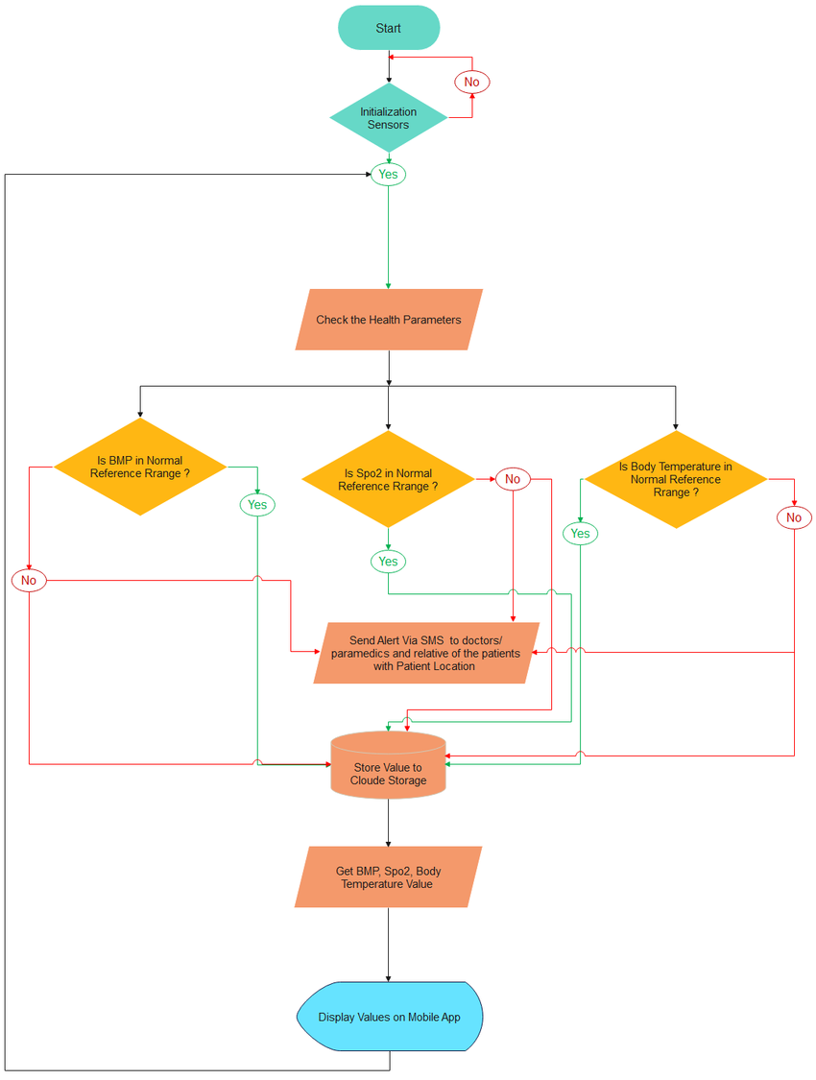Fig 5.3 Woking of health monitoring system

**5.4Algorithm**Convolutional Neural Networks (CNNs) are a critical component of the IoT-Enabled Smart Healthcare System, offering advanced capabilities for processing complex healthcare data and enabling precise anomaly detection. CNNs are designed to automatically extract meaningful patterns and features from high-dimensional data, such as time-series signals from wearable devices or medical images like X-rays and CT scans. The system uses convolutional layers to detect critical patterns, such as irregular heart rates, abnormal oxygen levels, or other health anomalies, without the need for manual feature engineering. Pooling layers follow the convolutional layers, reducing the dimensionality of the data while retaining essential information, making the processing more efficient and faster.

This hierarchical feature extraction allows CNNs to detect both simple and complex patterns, ensuring robust performance even in the presence of noisy data, which is common in IoT environments. The processed data is then classified through fully connected layers into normal or abnormal health states. If an anomaly is detected, real-time alerts are generated and sent to healthcare providers through the system's notification mechanisms.

By leveraging CNNs, the system can handle vast amounts of IoT data efficiently, ensuring scalability and adaptability. This makes CNNs an essential tool for delivering accurate, real-time health monitoring, enabling timely interventions, and improving overall patient outcomes.

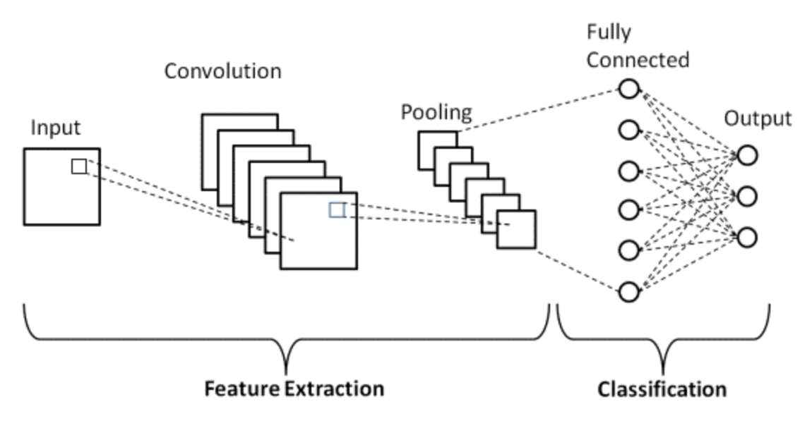

fig 5.4 Woking of CNN

**5.4.1 Recurrent Neural Networks (RNNs)**

Recurrent Neural Networks (RNNs) are essential for the IoT-Enabled Smart Healthcare System due to their ability to process sequential data and capture temporal dependencies, making them ideal for monitoring time-series health parameters such as heart rate, oxygen saturation, and temperature trends. Unlike traditional models, RNNs retain information from previous inputs using their internal memory, enabling them to analyze the progression of patient health over time. This capability is particularly useful for predicting future health risks based on historical data and detecting anomalies that might not be evident in single data points.

Long Short-Term Memory (LSTM) units, a type of RNN, are employed to address the vanishing gradient problem, ensuring the model captures long-term dependencies effectively. The system uses RNNs to continuously monitor health data streams, identify irregular patterns, and provide actionable insights in real-time. This predictive capability enhances proactive healthcare by alerting providers to potential risks before they escalate. By integrating RNNs into the IoT system, the healthcare monitoring solution becomes more robust, offering dynamic, real-time analysis and enabling personalized care through trend prediction and early anomaly detection, thereby improving patient outcomes and reducing emergency incidents.

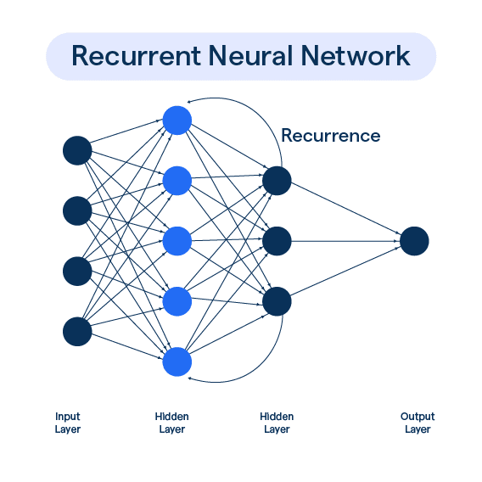  
fig 5.4.1 The RecurrentNeuralNetworks

**5.4.2 Sequential Minimal Optimization Algorithm (SMO)**

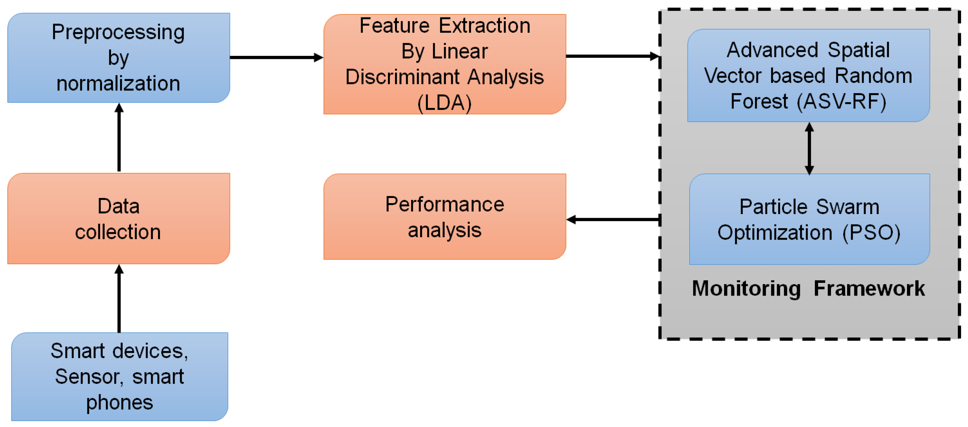The Sequential Minimal Optimization (SMO) algorithm is a key component in the IoT-Enabled Smart Healthcare System for its role in efficiently training Support Vector Machines (SVMs) for anomaly detection. SMO simplifies the complex quadratic programming problem in SVM training by breaking it into smaller sub-problems, allowing faster convergence. In this healthcare system, SMO processes health data from wearable sensors, such as heart rate and oxygen saturation, to classify patterns and detect anomalies indicative of potential health issues.

fig 5.4.2 Sequential Minimal Algorithm(flowchart)

By leveraging SMO, the system can handle large datasets typical of IoT applications while maintaining high computational efficiency. Its ability to process data in real-time ensures timely identification of critical conditions. The algorithm is robust against noisy data, which is common in IoT environments, and works well with high-dimensional feature sets, enhancing the accuracy of anomaly detection. Additionally, SMO’s lightweight computational requirements make it suitable for deployment on edge devices, such as the ESP32, enabling localized data processing. This integration of SMO into the healthcare monitoring system ensures a balance between speed and accuracy, facilitating real-time health assessments, early intervention, and improved patient outcomes while maintaining computational efficiency in resource-constrained IoT environments.

**5.4.3 Deep Learning Modified Neural Network (DLMNN)**

The Deep Learning Modified Neural Network (DLMNN), as shown in the image, is a crucial component of the IoT-Enabled Smart Healthcare System for Monitoring Patient Health and AI-Powered Anomaly Detection. It consists of multiple layers—input, hidden, and output—that work together to process and analyze complex healthcare data. The input layer receives patient data, such as heart rate, oxygen saturation, and body temperature, while the hidden layers perform hierarchical feature extraction using weighted connections and activation functions. Each node in the hidden layers processes weighted sums of the inputs, applies activation functions (e.g., ReLU or sigmoid), and passes the results forward.

This structure enables DLMNN to capture non-linear relationships and intricate patterns in patient health data, making it highly effective for anomaly detection and classification. By learning from historical and real-time data, the network improves its accuracy in predicting potential health risks. The output layer provides classification results, such as identifying normal or anomalous health states, which can trigger alerts for healthcare providers. The DLMNN’s ability to handle high-dimensional data and its adaptability make it a robust solution for delivering precise, real-time insights in smart healthcare systems.

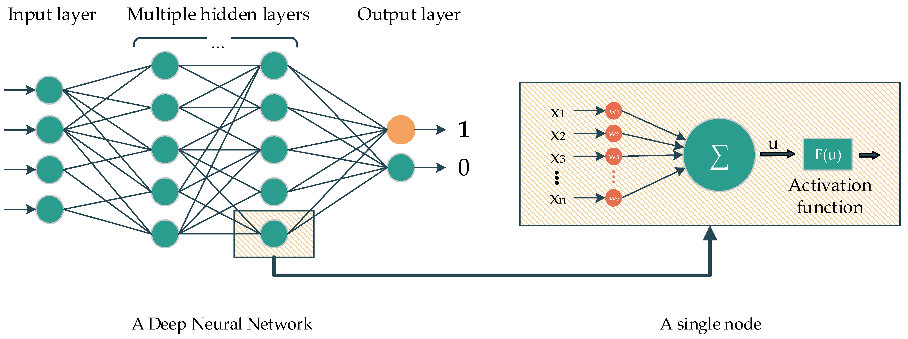

fig 5.4.2 Deep Learning Modified Neural Network.

**5.4.4 Hybrid Deep Learning Techniques**

The image illustrates the implementation of Hybrid Deep Learning Techniques in an IoT-Enabled Smart Healthcare System, combining real-time sensing, secure communication, and advanced data analysis for monitoring patient health. The Hybrid Sensing Network collects health data from wearable devices and environmental sensors, transmitting it through an IoT Smart Gateway to a centralized system. The gateway acts as a two-way proxy, enabling efficient communication between the sensors and the management application**.**

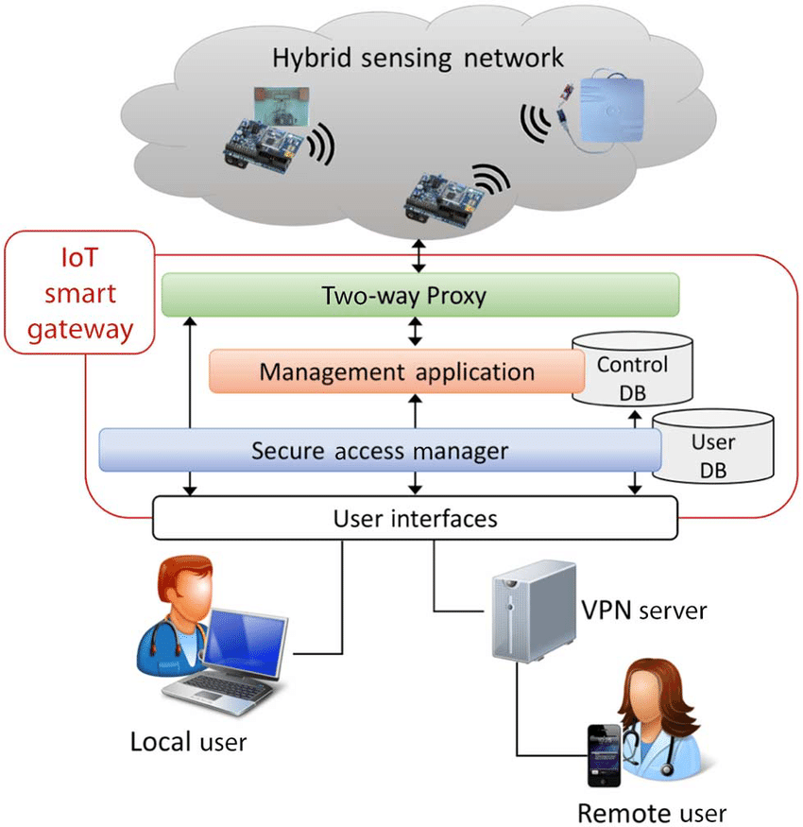

fig 5.4.4 Hybrid Deep Learning Techniques

A **Secure Access Manager** ensures that sensitive patient data is protected during transmission and storage by leveraging encryption and access control mechanisms. Data from sensors is processed using hybrid deep learning models that combine Convolutional Neural Networks (CNNs) for feature extraction and Recurrent Neural Networks (RNNs) for sequential data analysis. These models enable accurate anomaly detection and trend prediction.

The processed data is stored in databases (control and user DBs) and made accessible through **user interfaces**, allowing local and remote users, such as healthcare providers, to monitor patients in real-time. **VPN servers** ensure secure remote access for authorized users. This hybrid architecture supports efficient health monitoring, precise anomaly detection, and scalable remote healthcare delivery while ensuring data security and compliance with privacy standards.

**5.4.5 Deep Learning Anomaly Detection**

Deep Learning for anomaly detection in an IoT-Enabled Smart Healthcare System. The architecture consists of an input layer, hidden layers, and an output layer. The input layer receives data from wearable IoT devices, such as heart rate, oxygen saturation, and body temperature. These inputs are then processed through multiple hidden layers, where weights are adjusted to extract complex features and patterns within the data.

The hidden layers perform non-linear transformations, enabling the detection of subtle anomalies that may indicate critical health issues. The connections between neurons in successive layers allow the network to learn intricate relationships, enhancing the system's ability to distinguish between normal and abnormal health states. The output layer provides classifications, such as "normal" or "anomalous," triggering real-time alerts for healthcare providers in case of detected irregularities.

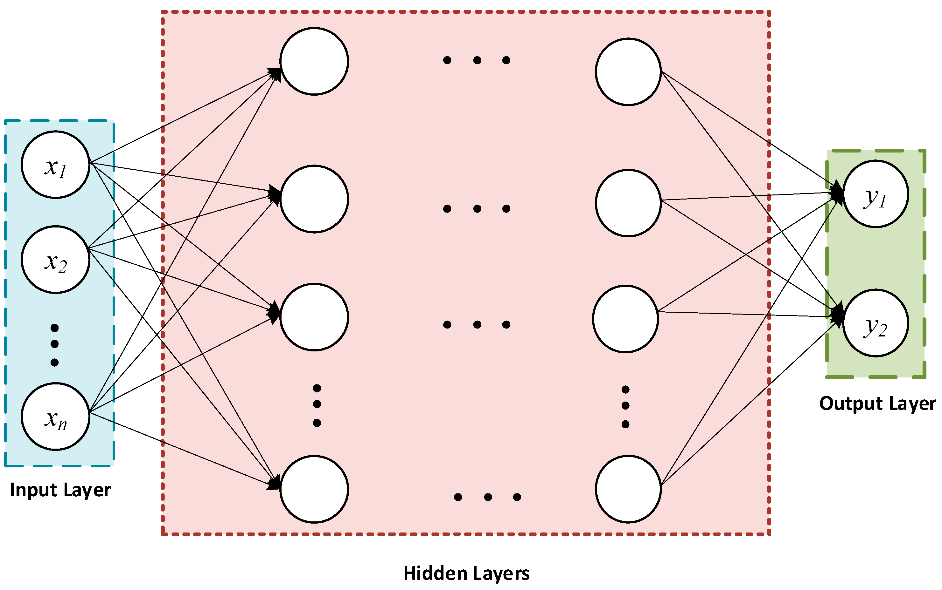  
fig 5.4.5 Deep Learning Anomaly Detection

This deep learning-based anomaly detection method ensures high accuracy by continuously learning from data, adapting to patient-specific health trends. It supports proactive healthcare by enabling early identification of potential risks, making the system a reliable tool for real-time monitoring and improved patient outcomes. The layered design ensures scalability and robustness, essential for large-scale IoT healthcare applications.

**5.4.6 Risk Detection Algorithms  
Risk Detection Algorithms** within an IoT-Enabled Smart Healthcare System for monitoring patient health and detecting anomalies. The framework begins with **data collection** from sensors, such as the MAX30100 for heart rate and SpO2 monitoring and the LM35 for temperature measurement, connected via ESP8266 microcontrollers. This sensor data, combined with user diet and fitness parameters, is stored in a centralized database for processing.

**Data analysis** leverages machine learning techniques, incorporating both supervised and unsupervised learning algorithms. Supervised learning identifies predefined health risks by mapping data to known conditions, while unsupervised learning clusters unknown patterns to detect new anomalies or trends. These algorithms enable real-time risk detection by analyzing sensor readings and user behavior.

The framework provides actionable insights through personalized recommendations, such as fitness and diet plans, displayed on an interactive **webpage** built using HTML and CSS. The closed-loop system ensures continuous monitoring and improvement, adapting to the user’s changing health data. This integration of hardware, data analysis, and risk detection algorithms ensures timely identification of potential health issues, enabling proactive interventions and improving patient outcomes in a scalable and efficient healthcare monitoring system.

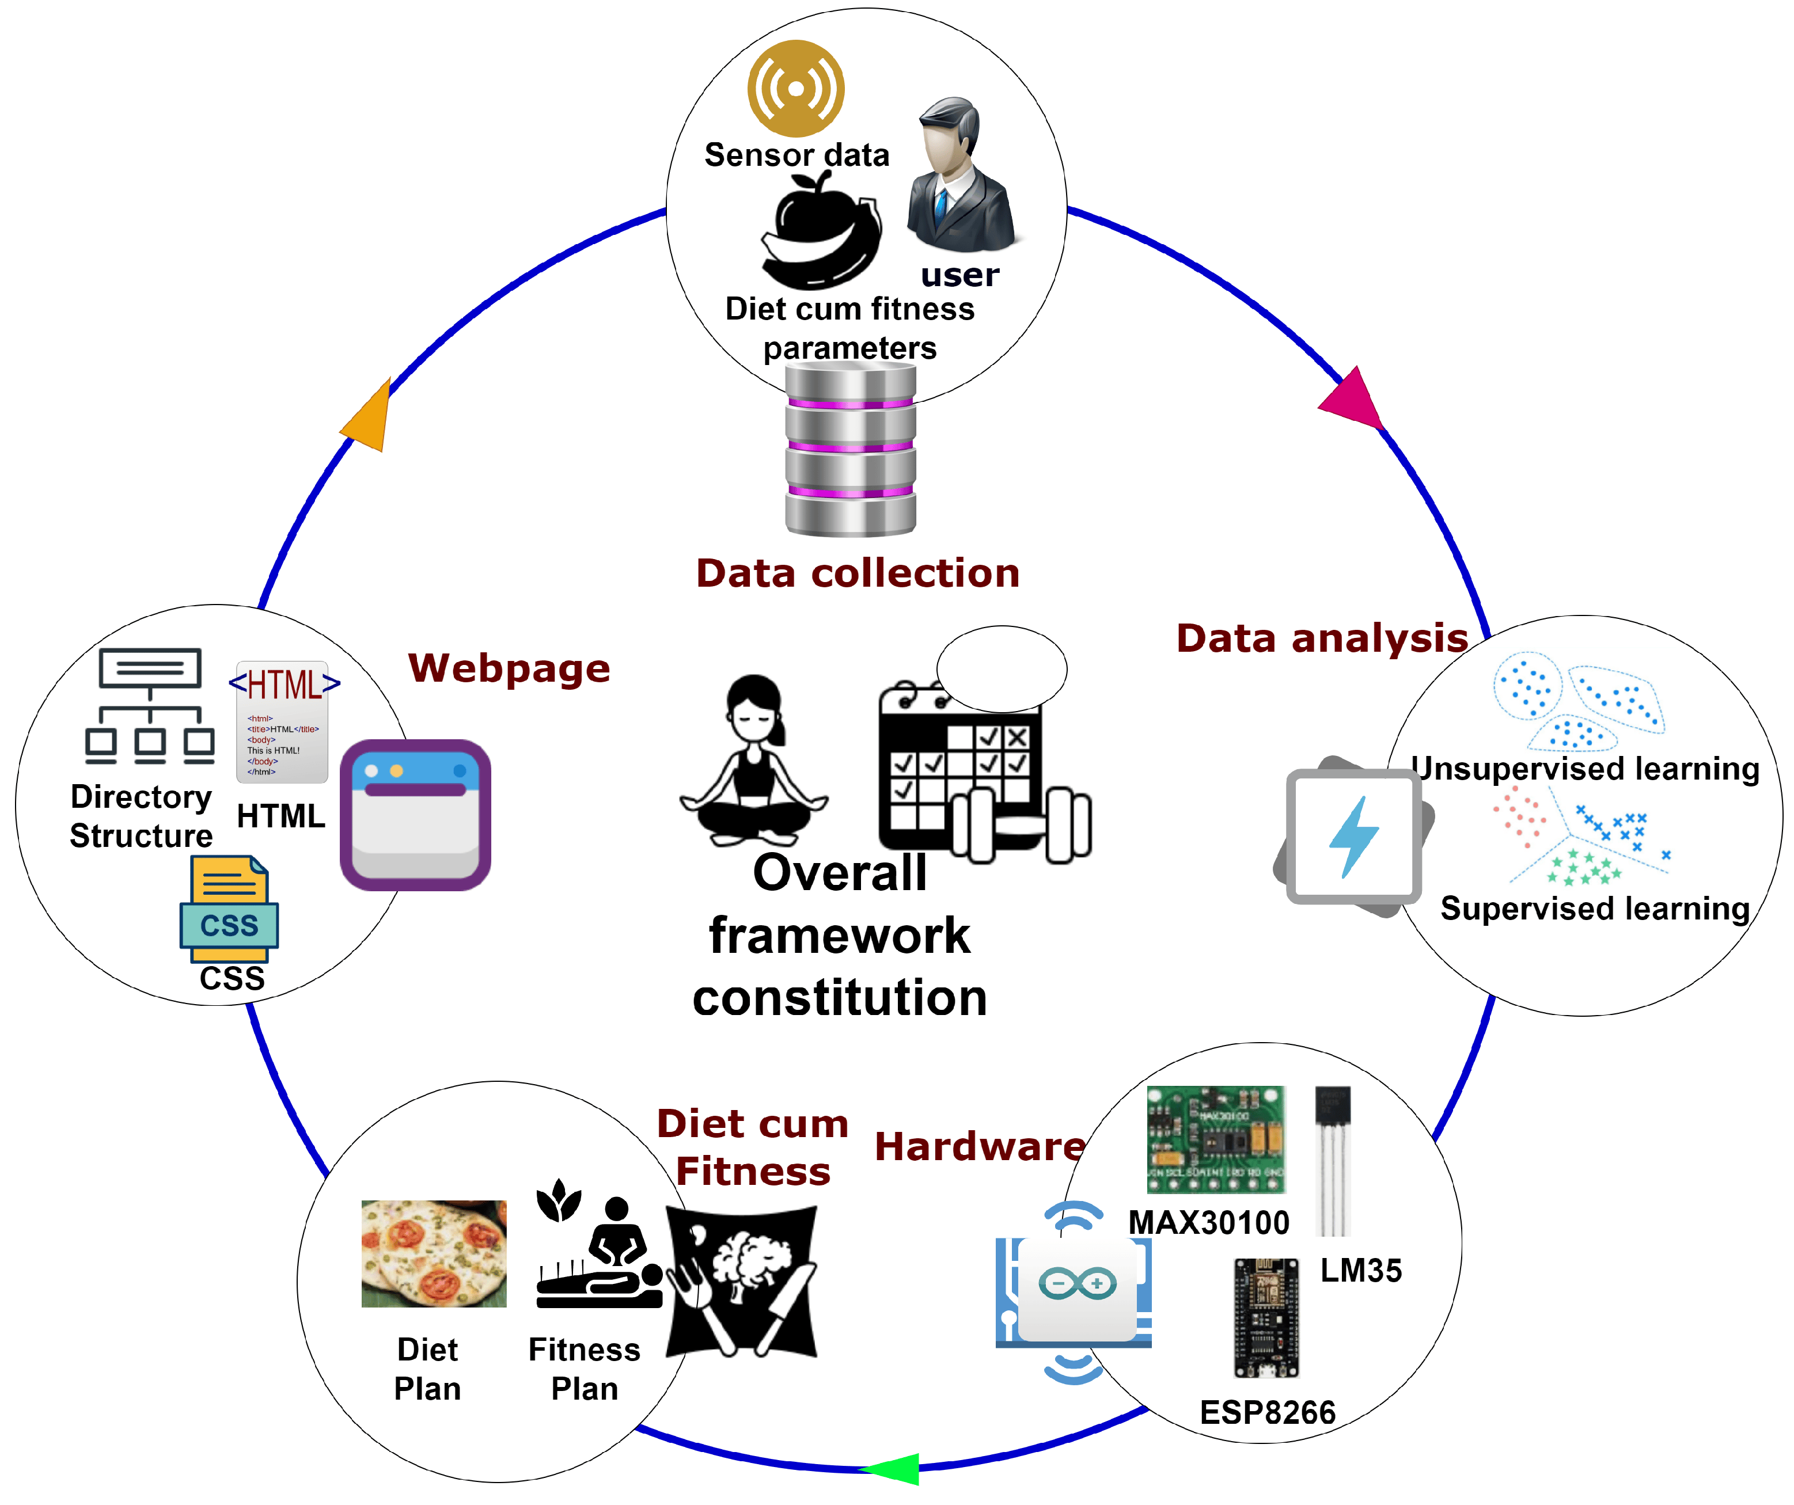

fig 5.4.6 Risk Detection Algorithm

This results in more secure and effective monitoring of health sessions, minimizing the risk of alerts and ensuring the integrity of the process.

**5.4.7 Pattern Recognition Techniques**Pattern Recognition Techniques in an IoT-Enabled Smart Healthcare System for monitoring patient health and anomaly detection. The system integrates sensors, such as ECG, body temperature, and blood pressure sensors, connected to an Arduino microcontroller. These sensors collect real-time health data, which is transmitted wirelessly via Wi-Fi to a cloud infrastructure for analysis. The cloud includes a database and web server to store, process, and display patient information.

Using pattern recognition techniques, the system identifies irregularities in sensor data by analyzing trends and deviations from normal health metrics. The algorithms process input data to classify it as normal or anomalous, enabling early detection of potential health risks. Results are displayed on an LCD or accessed remotely via mobile or web interfaces. The inclusion of an RFID reader ensures secure identification and personalized health tracking.

These techniques enhance the system’s ability to analyze complex, high-dimensional health data, ensuring real-time insights and timely intervention. By leveraging cloud-based processing and robust pattern recognition models, the system provides an efficient, scalable, and reliable solution for healthcare monitoring and proactive anomaly detection, improving patient outcomes and operational efficiency.

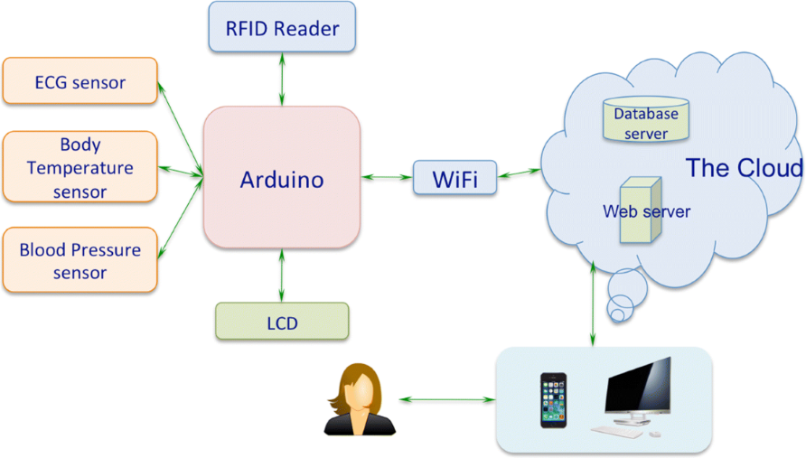

fig 5.4.6 Pattern Recognition Technique

**5.4.8 Data Preprocessing Algorithms**Data Preprocessing Algorithms in an IoT-Enabled Smart Healthcare System for monitoring patient health and anomaly detection. Data preprocessing is a critical step that ensures the quality and reliability of input data collected from various sources, such as wearable sensors and lifestyle factors. It addresses issues like missing values, no-response data, and incomplete entries (N/A) by cleaning, normalizing, and transforming the data into a usable format.

Once pre-processed, the cleaned data is analyzed using advanced machine learning and AI techniques to identify patterns and detect health anomalies.

.

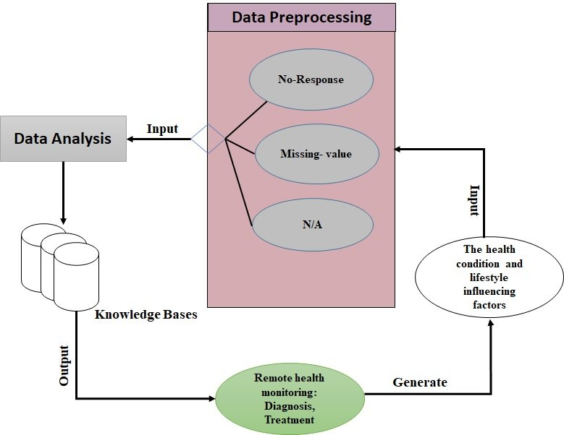  
fig 5.4.6 Data Pre-Processing Algorithm

The **data analysis module** integrates the processed input with knowledge bases, enabling the system to generate insights for remote health monitoring, diagnosis, and treatment recommendations. These outputs support healthcare providers by providing actionable information in real-time.

The iterative feedback loop ensures continuous learning and improvement of the system by refining its algorithms and knowledge bases based on new data. This preprocessing stage ensures that only high-quality, reliable data is fed into the system, improving the accuracy of anomaly detection and ensuring timely and effective interventions, making it a crucial component of the healthcare monitoring framework.

**5.4.9 Data Preprocessing Algorithms**

**Data Preprocessing Algorithms** in an IoT-Enabled Smart Healthcare System for monitoring patient health and anomaly detection. Data preprocessing is a critical step that ensures the quality and reliability of input data collected from various sources, such as wearable sensors and lifestyle factors. It addresses issues like **missing values**, **no-response data**, and incomplete entries (N/A) by cleaning, normalizing, and transforming the data into a usable format.

Once pre-processed, the cleaned data is analyzed using advanced machine learning and AI techniques to identify patterns and detect health anomalies.

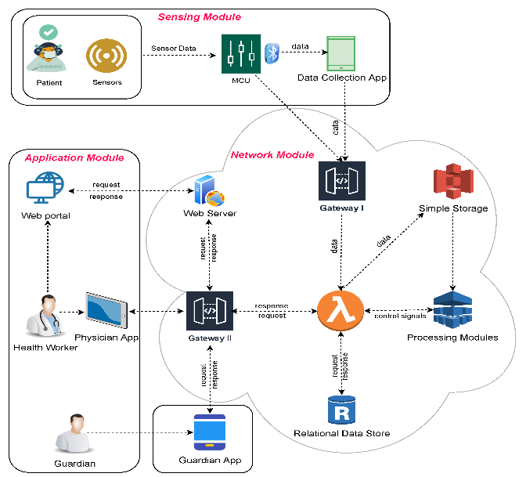  
fig 5.4.8 Data Pre-processing Algorithm

The **data analysis module** integrates the processed input with knowledge bases, enabling the system to generate insights for remote health monitoring, diagnosis, and treatment recommendations. These outputs support healthcare providers by providing actionable information in real-time.

The iterative feedback loop ensures continuous learning and improvement of the system by refining its algorithms and knowledge bases based on new data. This preprocessing stage ensures that only high-quality, reliable data is fed into the system, improving the accuracy of anomaly detection and ensuring timely and effective interventions, making it a crucial component of the healthcare monitoring framework.

**Chapter 6**

**OUTCOMES**

The AI-powered proctoring system uses a reinforcement model implemented with Convolutional Neural Networks (CNN). It is designed to verify the identity of students through facial recognition, track their behavior during the test, and flag any suspicious activity that may indicate cheating.

**6.1 Implementation Strategy:**

* **Step 1:** Collect real-time health data from wearable sensors, such as heart rate, oxygen saturation, body temperature.
* **Step 2**: Preprocess the collected data to remove noise, normalize values, and format it for analysis.
* **Step 3:** Import the necessary libraries and frameworks for IoT data handling, machine learning, and cloud integration.
* **Step 4:** Perform feature extraction using advanced techniques such as CNN algorithms for medical imaging or signal analysis, and preprocess sequential data for RNN-based modeling.
* **Step 5:** Analyze the extracted features to identify health patterns or detect anomalies by comparing them against predefined health thresholds or historical data in a cloud database.
* **Step 6**: If an anomaly (e.g., irregular heart rhythm or abnormal oxygen levels) is detected, the system triggers an alert to the connected health application or healthcare provider.
* **Step 7:** If critical health conditions persist (e.g., abnormal readings over a threshold duration), the system automatically escalates the alert to emergency contacts or medical responders.

**6.2 Hardware Platform Used:**

The system requires the following hardware components for smooth operation:

* **Intel i5 Processor or above**: To run AI models and handle the processing requirements.
* **4GB RAM**: Ensures sufficient memory to process data and run algorithms efficiently.
* **Monitor, Mouse, Keyboard**: Essential for interaction, monitoring during the reading.

**6.3 Software Platform Used:**

The following software platforms and tools are used in the development and execution of the proctoring system:

* **Operating System**: Windows 10 (Ensures compatibility with various software and frameworks).
* **Web Browser**: Google Chrome (Updated version) for the web-based platform.
* **Code Editor**: Arduino IDE (For writing and debugging the code).
* **Libraries and Frameworks**:
  + **HTTPClient.h**: Enables HTTP requests for sending and receiving data from web servers in IoT applications.
  + **ArduinoJson.h**: Facilitates parsing, generating, and manipulating JSON data for lightweight communication between devices and servers.
  + **Wire.h**: Supports I2C communication between microcontrollers and peripheral devices like sensors and displays.
  + **Adafruit_MPU6050.h**: Provides functionality to interface with the MPU6050 sensor for capturing accelerometer and gyroscope data.
  + **Adafruit_Sensor.h**: Offers a unified sensor interface for reading data from various Adafruit-supported sensors.
  + **DHT.h:** Enables reading temperature and humidity data from DHT11 or DHT22 sensors.
  + **LiquidCrystal.h:** Allows control of LCD screens for displaying real-time data from sensors.
  + **BlynkSimpleEsp32.h:** Integrates Blynk IoT platform for remote monitoring and control of ESP32-based devices.

**6.4 IoT-Enabled Smart Healthcare System for Monitoring**

|  |  |  |
| --- | --- | --- |
| **Features** | **Description** | **Functionality** |
| Real-Time Health Monitoring | Continuous collection of vital health parameters such as heart rate, oxygen saturation, and temperature. | Sensors provide real-time health data to ensure accurate and continuous tracking of patient health. |
| AI-Powered Anomaly Detection | Advanced algorithms detect irregularities in health metrics by analyzing patterns and deviations. | CNN and RNN models process sensor data to detect anomalies like irregular heart rhythms or abnormal oxygen levels, triggering timely alerts. |
| Alerts and Notifications | Immediate alerts for patients and healthcare providers when anomalies are detected. | The system sends real-time alerts to the healthcare application or provider when critical conditions are identified, ensuring timely interventions. |
| Data Privacy & Security | Secure handling of sensitive patient data and compliance with healthcare regulations (e.g., HIPAA). | Data encryption, access control, and secure storage mechanisms ensure privacy and security of health information. |
| Remote Monitoring | Enables remote access for healthcare providers to monitor patient data. | Physicians and caregivers can access real-time and historical health data via mobile and web applications, facilitating remote healthcare. |
| End-to-End Encryption | Secure transmission of health data between IoT devices, cloud storage, and applications. | All health data is encrypted during transmission to prevent unauthorized access and ensure patient confidentiality. |
| Predictive Health Analytics | Machine learning models analyze trends to predict potential health risks. | The system predicts conditions such as heart failure or respiratory issues, enabling proactive medical interventions. |

**6.5 Block Diagram**

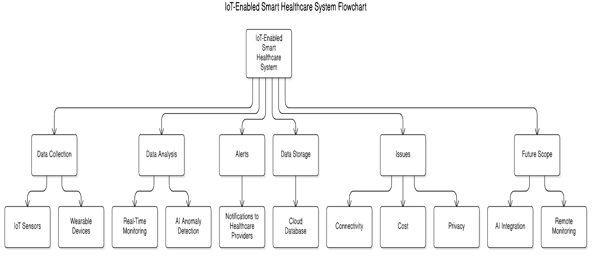

fig 6.5 Block Diagram

**6.6 Coding**

**6.6.1 ESP Code:**

// Blynk Credentials

#define BLYNK_TEMPLATE_ID "TMPL3HOOnHglA"

#define BLYNK_TEMPLATE_NAME "Health Detection"

#define BLYNK_AUTH_TOKEN "1IAKWAZnfqrcUd4fuEIZeuqhn4dVUSLc"

#include <HTTPClient.h>

#include <ArduinoJson.h>

#include <Wire.h>

#include <Adafruit_MPU6050.h>

#include <Adafruit_Sensor.h>

#include <DHT.h>

#include <LiquidCrystal.h>

#include <BlynkSimpleEsp32.h>

// Wi-Fi Credentials

char auth[] = "1IAKWAZnfqrcUd4fuEIZeuqhn4dVUSLc";

char ssid[] = "Mrhassain_"; // Replace with your Wi-Fi SSID

char pass[] = "qwertyuiop"; // Replace with your Wi-Fi password

// Flask Server URL

const char* serverUrl = "http://192.168.226.146:5000/data"; // Replace 192.168.1.x with Flask server IP

// Sensor Pins

#define DHTPIN 15 // DHT11 signal pin

#define DHTTYPE DHT11 // DHT type

// LCD Pins

LiquidCrystal lcd(4, 5, 14, 27, 26, 25);

// Initialize Sensors

DHT dht(DHTPIN, DHTTYPE);

Adafruit_MPU6050 mpu;

// Sensor Variables

int bpm = 80; // Simulated BPM

float spo2 = 98.5; // Simulated SPO2

float temperatureC = 0.0;

float humidity = 0.0;

int stepCount = 0; // Step count variable

// Motion Detection Variables

float accelX = 0.0, accelY = 0.0, accelZ = 0.0;

float prevMagnitude = 0.0;

float threshold = 1.2; // Adjust this threshold as needed

// Function to send data to Flask server

void sendToServer() {

if (WiFi.status() == WL_CONNECTED) {

HTTPClient http;

http.begin(serverUrl); // Connect to Flask server

http.addHeader("Content-Type", "application/json");

// Create JSON object

StaticJsonDocument<256> jsonDoc;

jsonDoc["BPM"] = bpm;

jsonDoc["SpO2"] = spo2;

jsonDoc["Temperature"] = temperatureC;

jsonDoc["Humidity"] = humidity;

jsonDoc["Steps"] = stepCount;

// Serialize JSON to string

String jsonData;

serializeJson(jsonDoc, jsonData);

// Send POST request

int httpResponseCode = http.POST(jsonData);

if (httpResponseCode > 0) {

String response = http.getString();

Serial.println("Response from Server: " + response);

} else {

Serial.println("Error sending data: " + String(httpResponseCode));

}

http.end();

} else {

Serial.println("WiFi Disconnected");

}

}

void setup() {

// Initialize Serial Monitor

Serial.begin(115200);

// Initialize LCD

lcd.begin(16, 2);

lcd.print("Initializing...");

delay(1000);

lcd.clear();

// Initialize DHT11

dht.begin();

lcd.print("DHT11 Ready");

delay(1000);

lcd.clear();

// Initialize MPU6050

if (!mpu.begin()) {

lcd.print("MPU6050 Error");

Serial.println("MPU6050 initialization failed!");

while (1);

}

lcd.print("MPU6050 Ready");

delay(1000);

lcd.clear();

// Initialize Blynk

Blynk.begin(auth, ssid, pass);

lcd.print("Blynk Connected!");

delay(1000);

lcd.clear();

}

void loop() {

Blynk.run();

// Simulate BPM and SPO2

bpm = random(70, 90); // Simulate heart rate between 70-90 BPM

spo2 = random(95, 100); // Simulate SpO2 between 95-100%

// Read DHT11 (Temperature & Humidity)

temperatureC = dht.readTemperature();

humidity = dht.readHumidity();

// Validate DHT11 Readings

if (isnan(temperatureC) || isnan(humidity)) {

Serial.println("Failed to read from DHT sensor! Check wiring.");

temperatureC = 0.0; // Default value for invalid temperature

humidity = 0.0; // Default value for invalid humidity

}

// Read Accelerometer Data

sensors_event_t a, g, temp;

mpu.getEvent(&a, &g, &temp);

accelX = a.acceleration.x;

accelY = a.acceleration.y;

accelZ = a.acceleration.z;

// Calculate Magnitude of Acceleration

float magnitude = sqrt(accelX * accelX + accelY * accelY + accelZ * accelZ);

// Step Detection Logic

if (magnitude > threshold && prevMagnitude <= threshold) {

stepCount++; // Increment step count on crossing threshold

}

prevMagnitude = magnitude;

// Print Data to Serial Monitor

Serial.println("Sensor Readings:");

Serial.print(" BPM: ");

Serial.println(bpm);

Serial.print(" SpO2: ");

Serial.println(spo2, 1);

Serial.print(" Temperature (°C): ");

Serial.println(temperatureC, 1);

Serial.print(" Humidity (%): ");

Serial.println(humidity, 1);

Serial.print(" Steps: ");

Serial.println(stepCount);

Serial.println("--------------------");

// Display Data on LCD

lcd.setCursor(0, 0);

lcd.print("BPM:");

lcd.print(bpm);

lcd.print(" SpO2:");

lcd.print(spo2, 1);

delay(1000);

lcd.setCursor(0, 1);

lcd.print("Steps:");

lcd.print(stepCount);

lcd.print(" Temp:");

lcd.print(temperatureC, 1);

delay(1000);

// Send Data to Flask Server

sendToServer();

// Send Data to Blynk

Blynk.virtualWrite(V1, bpm); // Send BPM to Virtual Pin V1

Blynk.virtualWrite(V2, spo2); // Send SpO2 to Virtual Pin V2

Blynk.virtualWrite(V3, temperatureC); // Send Temp to Virtual Pin V3

Blynk.virtualWrite(V4, humidity); // Send Humidity to Virtual Pin V4

Blynk.virtualWrite(V5, stepCount); // Send Step Count to Virtual Pin V5

delay(1000); // Update every second

}

**6.6.2 Flask Connection Code:**

import os

import json

from flask import Flask, request, jsonify

app = Flask(_name_)

# File to store sensor data

data_file = "latest_sensor_data.json"

# Precautions for anomalies

precautions = {

"BPM": "Consult a doctor if BPM is too high or low.",

"SpO2": "Increase oxygen intake or consult a healthcare provider.",

"Temperature": "Drink water, rest, or seek medical advice if fever persists.",

"Humidity": "Use a humidifier or dehumidifier as needed.",

"Steps": "Reduce excessive physical activity."

}

# Initialize the JSON file if it doesn't exist

if not os.path.exists(data_file):

with open(data_file, 'w') as file:

json.dump({}, file)

# Function to write data to the file

def write_to_file(data):

with open(data_file, 'w') as file:

json.dump(data, file)

# Function to read data from the file

def read_from_file():

with open(data_file, 'r') as file:

return json.load(file)

@app.route('/data', methods=['POST', 'GET'])

def receive_data():

if request.method == 'POST':

try:

# Log incoming JSON payload

incoming_data = request.json

print("Received Data:", incoming_data)

# Simulate anomaly detection

anomalies = {}

if incoming_data.get('BPM', 0) < 60 or incoming_data.get('BPM', 0) > 120:

anomalies['BPM'] = "Anomalous BPM detected!"

if incoming_data.get('SpO2', 0) < 92 or incoming_data.get('SpO2', 0) > 100:

anomalies['SpO2'] = "Anomalous SpO2 level detected!"

if incoming_data.get('Temperature', 0) < 35 or incoming_data.get('Temperature', 0) > 38:

anomalies['Temperature'] = "Temperature out of range!"

if incoming_data.get('Humidity', 0) < 20 or incoming_data.get('Humidity', 0) > 60:

anomalies['Humidity'] = "Humidity out of acceptable range!"

if incoming_data.get('Steps', 0) > 10000:

anomalies['Steps'] = "Unusual step count!"

# Log anomalies

if anomalies:

print("Anomalies Detected:", anomalies)

# Add anomalies to the data

incoming_data["anomalies"] = anomalies

# Write data to the file

write_to_file(incoming_data)

return jsonify({"status": "success", "anomalies": anomalies}), 200

except Exception as e:

print("Error:", e)

return jsonify({"status": "error", "message": str(e)}), 500

elif request.method == 'GET':

try:

# Read data from the file

data = read_from_file()

# Prepare response with anomalies and precautions

response = {

"data": data,

"anomalies": data.get("anomalies", {}),

"precautions": {

key: precautions[key] for key in data.get("anomalies", {}).keys()

}

}

return jsonify(response), 200

except Exception as e:

print("Error reading data:", e)

return jsonify({"status": "error", "message": str(e)}), 500

@app.route('/', methods=['GET'])

def health_check():

return jsonify({"status": "running", "message": "Flask server is running!"}), 200

if _name_ == '_main_':

app.run(host='0.0.0.0', port=5000, debug=True)

**Chapter 7**

**RESULTS AND DISCUSSIONS**

The implementation of the IoT-Enabled Smart Healthcare System involves several key steps to ensure reliability, security, efficiency, and scalability. The development process includes setting up the development environment, designing the system architecture, integrating machine learning algorithms, and deploying the system for real-time monitoring. Below is a detailed outline of the implementation process:

**Step 1: Git Integration for Version Control**  
Throughout the development process, Git is used for version control to manage the codebase and streamline collaboration among developers.

* **Git Repositories:** A GitHub repository is created to store project files, enabling easy collaboration and version tracking.
* **Branching and Merging:** Developers create branches for specific features or bug fixes, and changes are merged into the main branch after testing.
* **Commit Messages:** Meaningful commit messages are used to document changes, ensuring a clear history of modifications.
* **Collaboration:** Git allows developers to work on different parts of the system simultaneously and integrate their changes without conflicts.

**Step 2: Setting Up the Development Environment**  
The system is built using technologies such as Python, Flask, HTML, JavaScript, CSS, and MySQL.

* **IDE Usage:** Spyder is used for writing, testing, and debugging Python code.
* **IoT Integration:** Arduino IDE is employed to program microcontrollers (e.g., ESP32) for sensor data collection and communication.
* **GitHub Repository:** GitHub serves as the remote repository for storing and sharing project code.
* **Sensor Setup:** Wearable devices with sensors (e.g., heart rate, oxygen saturation) are connected to microcontrollers to collect real-time health data.

**Step 3: Designing the User Interface (UI)**  
The UI is designed to be user-friendly, intuitive, and accessible for patients, healthcare providers, and caregivers.

* **Healthcare Applications:** Interfaces are created for mobile and web platforms, displaying real-time health data, alerts, and historical trends.
* **Customization:** The UI is tailored to align with healthcare branding, ensuring a professional and cohesive design.

**Step 4: Implementing the Monitoring System with AI**The monitoring system integrates wearable sensors, IoT devices, and AI algorithms to ensure real-time health tracking.

* **Sensor Data Collection:** Sensors capture vital health metrics, including heart rate, body temperature, and oxygen levels.
* **Machine** **Learning Models:** AI algorithms, such as CNNs for pattern recognition and RNNs for trend prediction, process and analyze the data.
* **Real-Time Alerts:** The system generates alerts for healthcare providers if anomalies are detected, enabling timely interventions.

**Step 5: Deployment and Scalability**  
The system is deployed on cloud platforms for scalability and efficiency.

* **Data Processing and Storage:** Cloud servers handle data processing, storage, and analysis while ensuring security and compliance with healthcare regulations.
* **Remote Access:** The system allows healthcare providers and caregivers to access patient data remotely through secure web and mobile applications.

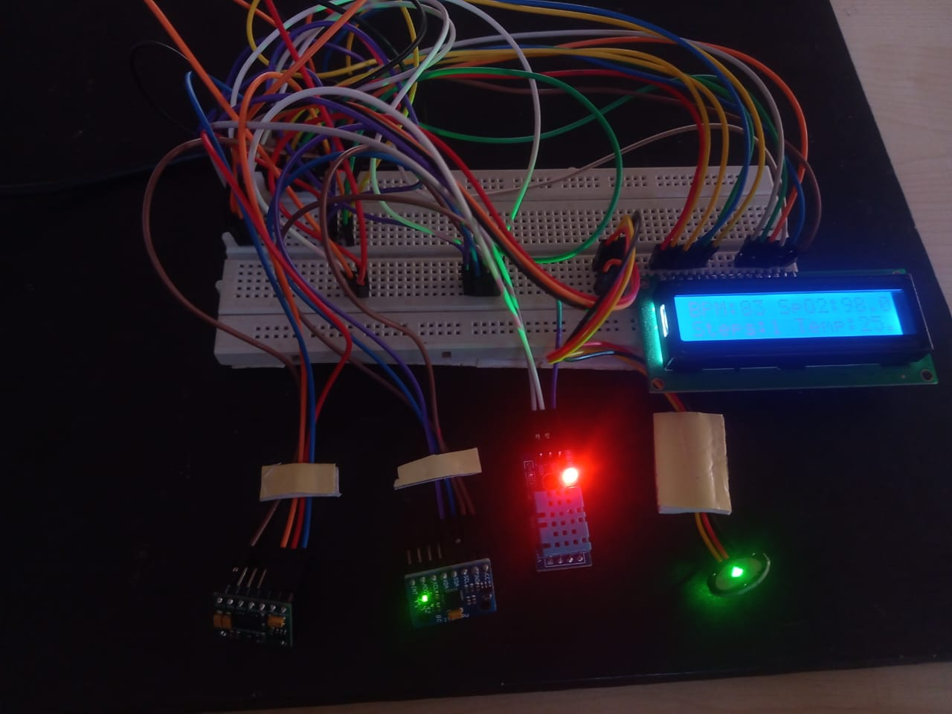  
Fig.7.1. Connection.

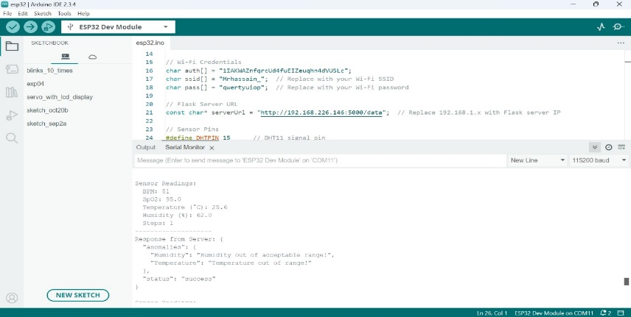  
Fig.7.2. Serial Monitor reading.

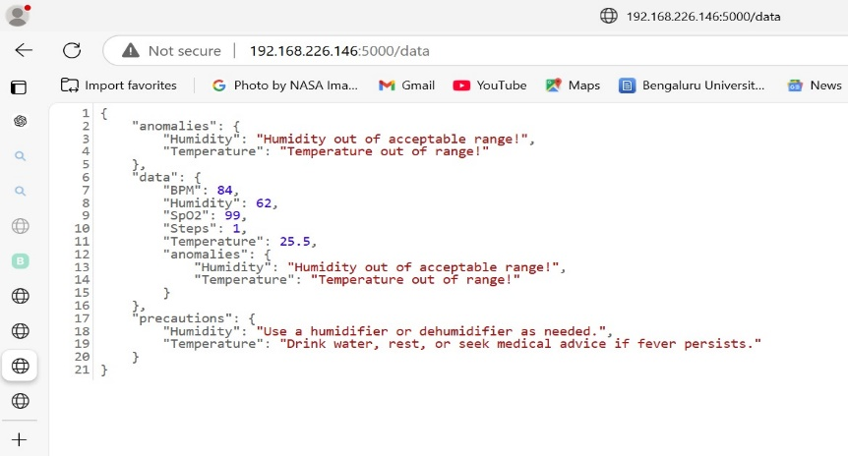

Fig.7.3. Anomaly Detection on Web.

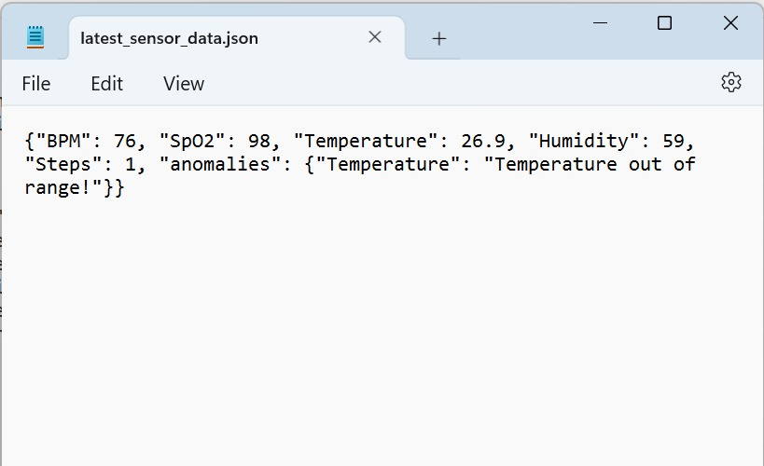

Fig.7.4. Data Stored in Json File.

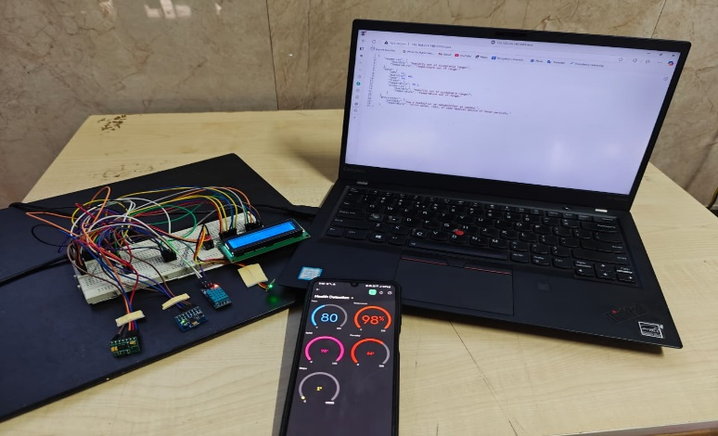

Fig.7.4. Final Set-Up.

**Chapter 8**

**CONCLUSION**

The **IoT-Enabled Smart Healthcare System for Monitoring Patient Health and AI-Powered Anomaly Detection** embodies a paradigm shift in how healthcare is delivered, combining the strengths of IoT, artificial intelligence, and advanced analytics to provide seamless, real-time health monitoring. This system addresses critical limitations in traditional healthcare practices, such as delayed responses, inadequate monitoring, and a lack of personalized care, by leveraging wearable devices, cloud computing, and machine learning models.

The system's architecture revolves around real-time data collection through wearable sensors that capture vital health metrics such as heart rate, body temperature, oxygen saturation, and ECG signals. Using microcontrollers like ESP32, this data is transmitted securely to cloud platforms, where AI-driven algorithms such as Convolutional Neural Networks (CNNs) and Recurrent Neural Networks (RNNs) analyze patterns and trends. This ensures accurate anomaly detection and predictive insights, empowering healthcare providers to act swiftly in case of irregularities or emerging health risks.

Moreover, the system incorporates robust features like real-time alerts, secure data handling, and compliance with healthcare regulations (e.g., HIPAA, GDPR), ensuring both reliability and trustworthiness. Remote monitoring capabilities enable healthcare professionals and caregivers to access patient data from anywhere, fostering a more proactive and patient-centric approach to care. The scalability of cloud integration also allows the system to accommodate increasing numbers of users and devices without compromising performance, making it suitable for diverse applications—from individual home-based care to hospital-scale implementations.

In addition to real-time monitoring, the predictive capabilities of the system stand out. By analyzing historical data and current trends, the AI algorithms can forecast potential health risks, enabling preventive measures to be taken before critical conditions arise. This predictive edge not only improves patient outcomes but also reduces the burden on healthcare systems by minimizing emergency cases.

Overall, the **IoT-Enabled Smart Healthcare System** demonstrates how technology can revolutionize healthcare by enhancing efficiency, accessibility, and quality of care. It represents a scalable, secure, and innovative solution to modern healthcare challenges, paving the way for a future where health monitoring is proactive, personalized, and seamlessly integrated into daily life. By combining cutting-edge technology with a user-centric approach, this system exemplifies the potential of IoT and AI to transform global healthcare and improve the quality of life for millions.

**APPENDICES**

**Appendix A: Key Code Components**

1. **Sensor Data Collection Module**:
   * Collects health data (e.g., heart rate, oxygen saturation) using DHT, Adafruit_MPU6050, and other sensors.
   * Manages real-time sensor communication via sensor_data_collection, sensor_service.
2. **Data Preprocessing Module**:
   * Cleans and formats raw data for AI model input.
   * Handles missing values and noise reduction using data_preprocessing_service.
3. **Anomaly Detection Module**:
   * Detects irregularities in health metrics using CNNs and RNNs.
   * Compares health metrics with thresholds or historical data using anomaly_detection_service.
4. **Alert Notification Module**:
   * Triggers alerts for healthcare providers or caregivers during anomalies.
   * Utilizes notification_service to send alerts through mobile or web apps.

**Appendix B: System Architecture**

* **Multi-Layered Design**:
  + **Client Layer**: User interfaces for patients and healthcare providers.
  + **Server Layer**: AI-driven health data analysis and anomaly detection.
  + **Cloud Layer**: Secure data storage, real-time processing, and analytics.

**Appendix C: User Interfaces**

1. **Login Page**:
   * Allows secure login for patients, caregivers, and healthcare providers.
2. **Health Dashboard**:
   * Displays real-time health metrics, historical data, and alerts.
   * Includes options to download reports or share data with healthcare providers.

**Appendix D: Database Schema**

1. **Users Table**:
   * Stores login credentials and user roles (e.g., patient, provider, caregiver).
2. **Health Data Table**:
   * Stores real-time and historical sensor data.
3. **Alerts Table**:
   * Stores alert information, including timestamps and reasons for the alert.

**Appendix E: Anomaly Detection Flow**

1. **Health Metrics Validation**:
   * Validates sensor readings against predefined thresholds.
2. **Anomaly Monitoring**:
   * Flags anomalies in real-time using AI models (e.g., CNN, RNN).
3. **Alert Generation**:
   * Sends notifications for detected anomalies to the healthcare app or provider.

**Appendix F: System Requirements**

* **Software**:
  + Python 3, Flask, Arduino IDE, PostgreSQL.
* **Hardware**:
  + ESP32 microcontroller, wearable sensors (DHT11, MAX30100), LCD display, Intel i5 processor, 8GB RAM.

**Appendix G: Ethical Considerations**

* **Compliance**:
  + Adheres to GDPR and HIPAA regulations for data protection.
* **Data Security**:
  + Ensures encrypted data storage and secure transmission to protect patient privacy.

**Appendix H: Deployment and Integration**

* **Cloud Integration**:
  + Uses AWS or Google Cloud for data storage and processing.
* **Modular Deployment**:
  + Docker containers used for deploying individual modules (e.g., sensor data collection, anomaly detection).
* **Real-Time Monitoring**:
  + Monitors health metrics continuously and escalates critical anomalies to emergency responders when necessary.

**REFERENCES**

* G Prasad, P Gujjar, HNN Kumar, MA Kumar… - Cyber Trafficking, Threat Behavior, and Malicious , 2023
* Imoize, Agbotiname Lucky, et al., eds. *Handbook of Security and Privacy of AI-Enabled Healthcare Systems and Internet of Medical Things*. CRC Press, 2023.
* Kalusivalingam, Aravind Kumar, et al. "Enhancing Patient Care Through IoT-Enabled Remote Monitoring and AI-Driven Virtual Health Assistants: Implementing Machine Learning Algorithms and Natural Language Processing." *International Journal of AI and ML* 2.3 (2021).
* Tiwari, Meena, and Akhilesh A. Waoo. "Transforming Healthcare: The Synergistic Fusion of AI and IoT for Intelligent, Personalized Well-Being." *Revolutionizing Healthcare: AI Integration with IoT for Enhanced Patient Outcomes*. Cham: Springer Nature Switzerland, 2024. 109-149.
* Bhambri, Pankaj, and Alex Khang. "Managing and Monitoring Patient's Healthcare Using AI and IoT Technologies." In *Driving Smart Medical Diagnosis Through AI-Powered Technologies and Applications*, pp. 1-23. IGI Global, 2024.
* SEDDIKI, M., BOUHEDDA, M., TOBBAL, A., REBOUH, S., & ANIBA, Y. (2024). AI-Driven IoT Healthcare System for Real-Time ECG Analysis and Comprehensive Patient Monitoring. *Science, Engineering and Technology*, *4*(2), 61-81.
* Bajpayi, P., Sharma, S., & Gaur, M. S. (2024, March). AI Driven IoT Healthcare Devices Security Vulnerability Management. In *2024 2nd International Conference on Disruptive Technologies (ICDT)* (pp. 366-373). IEEE.
* Kumar A, Jain R, Gupta M, Islam SM, editors. 6G-enabled IoT and AI for smart healthcare: Challenges, impact, and analysis. CRC Press; 2023 Jun 21.
* Awad, Ali Ismail, et al. "AI-powered biometrics for Internet of Things security: A review and future vision." *Journal of Information Security and Applications* 82 (2024): 103748.
* David, Jameson. "Revolutionizing Biomedical Engineering: AI-Driven Medical Devices in Cloud-Based Healthcare Systems." (2024).
* Rangasamy, Sangeetha, et al. "Revolutionizing Healthcare with IoT: Connecting the Dots for Better Patient Outcomes." *AI and IoT Technology and Applications for Smart Healthcare Systems*. Auerbach Publications, 2024. 204-223.